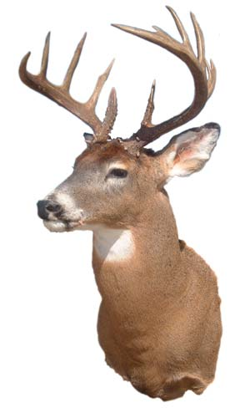
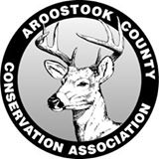
Aroostook County
Conservation Association
15th ANNUAL
ACCA COYOTE CONTROL PROGRAM 2023 – 2024
Don’t miss your chance! Advertise as a business that cares about our Whitetail deer herd and our way of life!
(Please Print)
NAME: __________________________________________________________________
ADDRESS: _______________________________________________________________
CITY: ________________________________STATE: ___________ ZIP: _____________
PHONE: ___________________________________________________________________
EMAIL: ___________________________________________________________________
WEBSITE: ________________________________________________________________
Has donated ____$50 ____$100 $ __________ (other) toward the 15th Annual ACCA
Coyote Control Program which runs from October 15, 2023 to March 09, 2024.
Your donations are tax deductible. The ACCA is a non-profit organization and our EIN is 46-4964531.
All $100.00 sponsors will receive a link from the ACCA website.
All sponsor names will be posted on the ACCA website. Please advise us if you want to stay anonymous. Check here __________ for anonymity.
Thank you for your help!
Make checks payable to: ACCA
Mail to: 41 Hedman Road, New Sweden, ME 04762

Jerry McLaughlin – President Cell: 207-592-2516; Home: 207-896-3140
Website is: accamaine.com
Facebook is: Acca-Maine Friends-page

Received on ______/______/______ by _______________________________________

